Understanding Custom Prompt Behaviour in ChatDSI:

When using ChatDSI for translation purposes, it is important to frame the custom prompt correctly to ensure the assistant behaves as expected. If the prompt is generic, the model may try to interpret and answer questions rather than simply translating them.

Below are two common use cases and how to structure the custom prompt accordingly:

1. **Translating All Prompts (Questions) into German**
   * Custom Prompt: **"Please translate all the queries asked to you in German."**

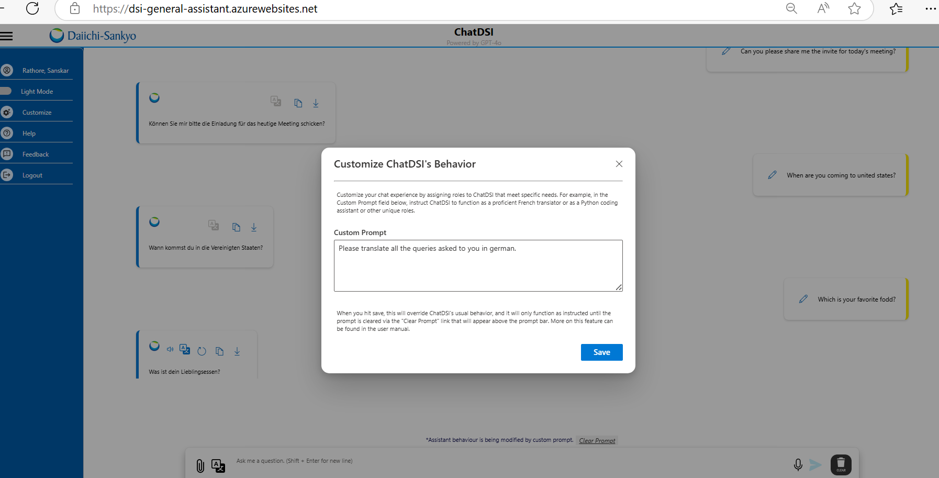

* + Behaviour:

1. **Answering All Questions in German**
   * Custom Prompt: **"Answer all the questions in German."**

* + Behaviour: A screenshot of a computer

    AI-generated content may be incorrect.

### **Why Some Prompts May Not Work as Expected**

In some cases, prompts such as "Act as an English to German translator" may partially work but not consistently produce the desired behaviour. For example, if the prompt is vague or includes open-ended instructions, ChatDSI may:

* Try to interpret or answer the input instead of translating it.
* Respond in English if the intent is unclear.
* Handle certain types of questions (e.g., current time, weather, or factual lookups) in its default behaviour.